|  |
| --- |
| Team 10 |
| **Compiler Term-Project #1** |
| The implementation of a lexical analyzer |

|  |  |
| --- | --- |
| Date | May 9, 2020 |
| Instructor | Hyosu Kim |
| Team | #10 |
| Members | Heesang Ro (20145001)  Junhyuck Woo (20145337) |



# INDEX

INDEX 1

LEXICAL SPECIFICATIONS 2

TOKENS 3

REGULAR EXPRESSION 4

NFA (Non-deterministic Finite Automata) 5

1. ID 5

2. INTEGER 6

3. FLOAT 8

4. LITERAL 11

DFA (Deterministic Finite Automata) 12

1. ID 12

2. INTEGER 14

3. FLOAT 15

4. LITERAL 17

TROUBLE & SOLUTION 19

1. Longest matching 19

2. Period 20

3. Error 21

IMPLEMENTATION 22

1. Tokens, Alphabet 22

2. ID-DFA 23

3. INTEGER - DFA 24

4. FLOAT - DFA 25

5. LITERAL - DFA 26

TEST CASES & RESULT 27

1. Correct Test Code - I 27

2. Correct Test Code - II 28

3. Error Test Code - I 29

APPENDIX 30

1. NFA to DFA with transition table 30

# LEXICAL SPECIFICATIONS

|  |
| --- |
| **Variable type**   * int fir a signed integer * char for a literal string * bool for a Boolean string * float for a floating-point umber   **Signed integer**   * A single zero digit * A non-empty sequence of digits, starting from a non-zero digit * A non-empty sequence of digits, starting from a minus sign symbol and a non-zero digit   **Literal string**   * Any combination of digits, English letters, and blanks, starting from and terminating with a symbol “   **Boolean string**: true and false  **Floating-point number**   * A sequence that meets the following conditions:  1. It starts with or without a negative sign symbol 2. . (a decimal point) appears only once 3. Scientific/exponential symbols like E are not allowed 4. Both left and right side of the decimal point must not be empty sequence 5. The left side of a decimal point must be a single digit 0 or a non-empty sequence starting from a non-zero digit 6. The right side of a decimal point must be a single digit 0 or a non-empty sequence terminating with a non-zero digit   **An identifier of variables and functions**   * A non-empty sequence of English letters, digits, and underscore symbols, starting from an English letter or a underscore symbol   **Keywords for special statements**   * if for if statement * else for else statement * while for while-loop statement * for for for-loop statement * return for return statement   **Arithmetic operators**: +, -, *, and /  **Bitwise operator**: <<, >>, &, and |  **Assignment operator**: =  **Comparison operators**: <, >, ==, !=, <=, and >=  **A terminating symbol of statements**: ;  **A pair of symbols for defining area/scope of variables and functions**: { and }  **A pair of symbols for indicating a function/statement**: ( and )  **A symbol for separating input arguments in functions**: ,  **Whitespaces**: a non-empty sequence of \t, \n, and blanks |

# TOKENS

|  |  |
| --- | --- |
| Token | Lexeme |
| VARIABLE | int, float, char, bool |
| KEYWORD | if, else, while, for, return |
| LOGIC | true, false |
| ID | i, j, k, ab_123, func1, func_, __func_bar__, …… |
| INTEGER | 0, 1, 22, 123, 56, -1, -22, -123, -56, …… |
| FLOAT | 0.5, 0.0, -10.0, 100.00001, ,,,,, |
| LITERAL | “Hello world”, “My student id is 12345678”, …… |
| OPERATOR | +, -, *, /, <<, >>, &, | |
| COMPARISON | <, >, ==, !=, <=, >= |
| WHITESPACE | , \t, \n |
| BRACE | {, } |
| PAREN | (, ) |
| ASSIGN | = |
| TERM | ; |
| COMMA | , |

# REGULAR EXPRESSION

Alphabet (Σ)

* A, B, C, D, E, F, G, H, I, J, K, L, M, N, O, P, Q, R, S, T, U, V, W, X, Y, Z, a, b, c, d, e, f, g, h, i, j, k, l, m, n, o, p, q, r, s, t, u, v, w, x, y, z, 0, 1, 2, 3, 4, 5, 6, 7, 8, 9, +, -, *, /, <, &, |, =, ;, , {, }, (, ), ., ,

Symbol

* zero = 0
* non-zero = 1 | 2 | 3 | 4 | 5 | 6 | 7 | 8 | 9
* letter = A | B | C | D | E | F | G | H | I | J | K | L | M | N | O | P | Q | R | S | T | U | V | W | X | Y | Z | a | b | c | d | e | f | g | h | i | j | k | l | m | n | o | p | q | r | s | t | u | v | w | x | y | z

|  |  |
| --- | --- |
| Token | Regular Expression |
| ID |  |
| INTEGER |  |
| FLOAT |  |
| LITERAL |  |
| VARIABLE |  |
| KEYWORD |  |
| LOGIC |  |
| OPERATOR |  |
| COMPARISON |  |
| WHITESPACE |  |
| BRACE |  |
| PAREN |  |
| ASSIGN | = |
| TERM | ; |
| COMMA | , |

# NFA (Non-deterministic Finite Automata)

Our team implemented the NAF (Non-deterministic Finite Automata) with the McNaughton-Yamada-Thompson algorithm. We only handle 4 kinds of tokens, and the other tokens will be implemented as code without a transition table.

## 1. ID

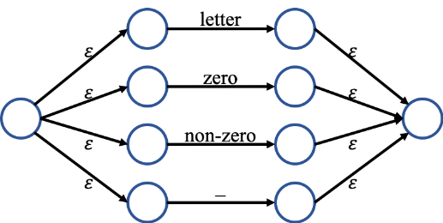

## 2. INTEGER

* ,

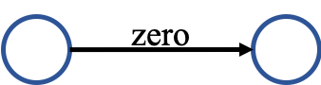 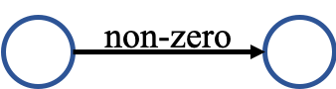

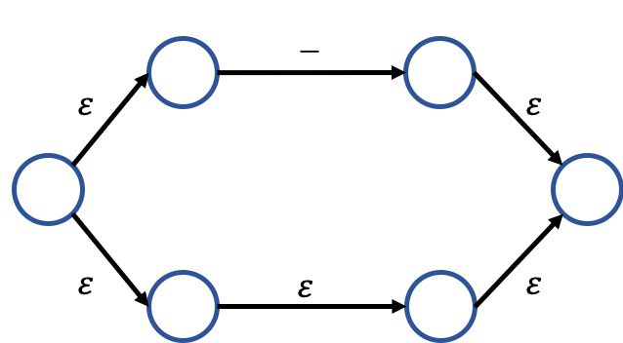

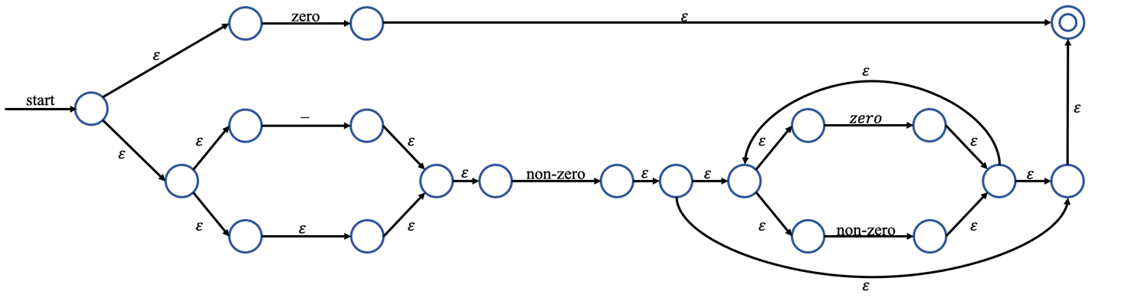

## 3. FLOAT

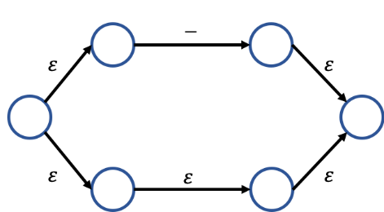

* , .

  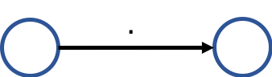

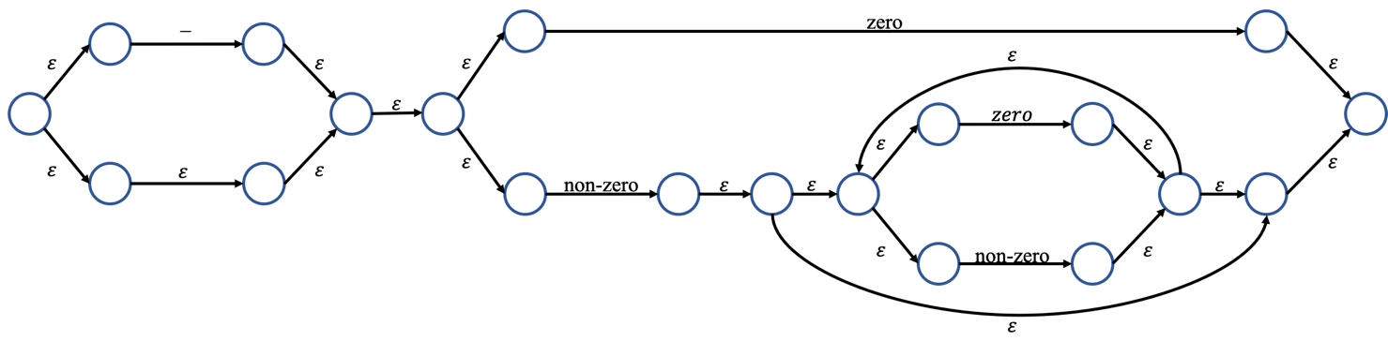

## 4. LITERAL

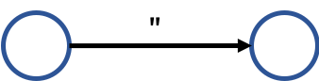

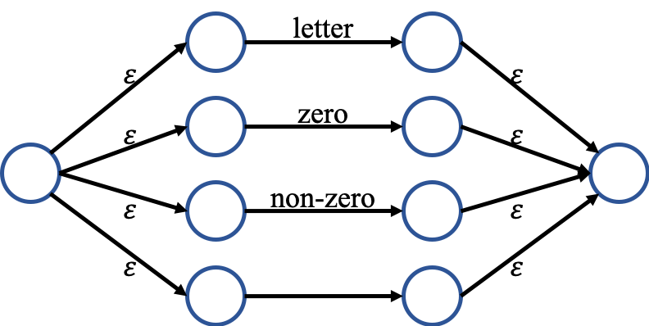

# DFA (Deterministic Finite Automata)

We built DFA graph and transition table using subset (powerset) construction algorithm.

If you want to see the hand-writing paper, please check the appendix.

## 1. ID

|  |
| --- |
| = {A, B, C} = T0 |
| = = {D, F, G, H, I, J, K, L, R} = T1  =  =  = = {E, F, G, H, I, J, K, L, R} = T2 |
| = = {M, Q, R, H, I, J, K, L} = T3  = = {N, Q, R, H, I, J, K, L} = T4  = = {O, Q, R, H, I, J, K, L} = T5  = = {P, Q, R, H, I, J, K, L} = T6 |
| = = T3  = T4  = = T5  = = T6 |
| = = T3  = T4  = = T5  = = T6 |
| = = T3  = T4  = = T5  = = T6 |
| = = T3  = T4  = = T5  = = T6 |
| = = T3  = T4  = = T5  = = T6 |

* Transition table

|  |  |  |  |  |
| --- | --- | --- | --- | --- |
|  | letter | zero | non-zero | _ |
| * T0 | T1 |  |  | T2 |
| *T1* | T3 | T4 | T5 | T6 |
| *T2* | T3 | T4 | T5 | T6 |
| *T3* | T3 | T4 | T5 | T6 |
| *T4* | T3 | T4 | T5 | T6 |
| *T5* | T3 | T4 | T5 | T6 |
| *T6* | T3 | T4 | T5 | T6 |

* DFA Graph

## 2. INTEGER

|  |
| --- |
| = {A, B, C, D, E, G, H, I} = T0 |
| = = {F, H, I} = T1  = = {T, S} =T2  = = {J, K, L, M, N, R, S} =T3 |
| =  =  = = T3 |
| =  =  =  = |
| = {O, Q, L, M, N, R, S} = T4  = = {P, Q, L, M, N, R, S} = T5 |
| =  = T4  = = T5 |
| =  = T4  = = T5 |

* DFA Graph
* 실외, 잔디, 빨간색, 평야이(가) 표시된 사진

  자동 생성된 설명Transition table

|  |  |  |  |
| --- | --- | --- | --- |
|  | - | zero | non-zero |
| * T0 | T1 | T2 | T3 |
| T1 |  |  | T3 |
| *T2* |  |  |  |
| *T3* |  | T4 | T5 |
| *T4* |  | T4 | T5 |
| *T5* |  | T4 | T5 |

## 3. FLOAT

|  |
| --- |
| = {1, 2, 3, 4, 6, 7, 8, 10} = T0 |
| = = {5, 6, 7, 8, 10} = T1  = = {9, 20, 21} =T2  = = {11, 12, 13, 14, 16, 19, 20, 21} =T3  = |
| =  = = T2  = = T3  = |
| =  =  =  = = {22, 23, 24, 30, 31, 32, 34, 37, 38} = T4 |
| =  = {13, 14, 15, 16, 18, 19, 20, 21} = T5  = {13, 14, 16, 17, 18, 19, 20, 21} = T6  = = T4 |
| =  = {25, 31, 32, 33, 34, 36, 37, 38, 40} = T7  = = {31, 32, 34, 35, 36, 37, 38, 39, 40} = T8  = |
| =  = T5  = = T6  = = T4 |
| =  = T5  = = T6  = = T4  = |

= {31, 32, 33, 34, 36, 37, 38} = T9

|  |
| --- |
| = = T8  = |
| =  = T9  = = T8  = |
| =  = T9  = = T8  = |

* Transition table

|  |  |  |  |  |
| --- | --- | --- | --- | --- |
|  | - | zero | . | non-zero |
| * T0 | T1 | T2 |  | T3 |
| T1 |  | T2 |  | T3 |
| T2 |  |  | T4 |  |
| T3 |  | T5 | T4 | T6 |
| T4 |  | T7 |  | T8 |
| T5 |  | T5 | T4 | T6 |
| T6 |  | T5 | T4 | T6 |
| T7 |  | T9 |  | T8 |
| T8 |  | T9 |  | T8 |
| T9 |  | T9 |  | T8 |

* DFA Graph

## 4. LITERAL

|  |
| --- |
| = {A} = T0 |
| = = {B, C, D, E, F, G, H, N, O} = T1  =  =  =  = |
| = = {P} = T2  = = {I, M, N, O, D, E, F, G, H} = T3  = = {J, M, N, O, D, E, F, G, H} = T4  = = {K, M, N, O, D, E, F, G, H} = T5  = = {L, M, N, O, D, E, F, G, H} = T6 |
| =  =  =  =  = |
| = = T2  = = T3  = T4  = = T5  = = T6 |
| = = T2  = = T3  = T4  = = T5  = = T6 |
| = = T2  = = T3  = T4  = = T5  = = T6 |
| = = T2  = = T3  = T4  = = T5  = = T6 |

* Transition table

|  |  |  |  |  |  |
| --- | --- | --- | --- | --- | --- |
|  | “ | letter | zero | non-zero |  |
| * T0 | T1 |  |  |  |  |
| T1 | T2 | T3 | T4 | T5 | T6 |
| *T2* |  |  |  |  |  |
| T3 | T2 | T3 | T4 | T5 | T6 |
| T4 | T2 | T3 | T4 | T5 | T6 |
| T5 | T2 | T3 | T4 | T5 | T6 |
| T6 | T2 | T3 | T4 | T5 | T6 |

* DFA Graph

# TROUBLE & SOLUTION

## 1. Longest matching

* Trouble

When we tested identifier that includes keyword and variable (e.g. if, while, int, char), longest matching didn’t work well.

|  |  |  |
| --- | --- | --- |
| Input | Expected result | Result |
|  | ……  VARIABLE int  ID int_ABC  ASSIGN =  …… | ……    …… |

* Solution

We add more if condition in variable, keyword, logic part so that our program can do longest matching.

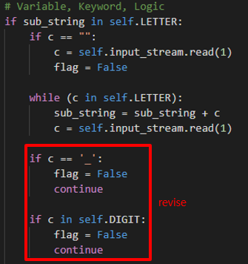

* Result

|  |  |  |
| --- | --- | --- |
| Input | Previous result | Revised result |
|  | ……    …… |  |

## 2. Period

* Trouble

When we tested . (Period) without any prefix, our program is finished that line.

|  |  |  |
| --- | --- | --- |
| Input | Expected result | Result |
|  | Line2 error! | Program is finished unexpected. |

* Solution

At first, our program didn’t include the condition that what we did if the first substring is . (Period). So, we add . (Period) condition in our program.

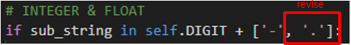

* Result

|  |  |  |
| --- | --- | --- |
| Input | Previous result | Revised result |
|  | Program is finished unexpected. |  |

## 3. Error

* Trouble

When we tested wrong inputs like 33abc, 3.3test, our program didn’t get the error.

|  |  |  |
| --- | --- | --- |
| Input | Expected result | Result |
|  | Line2 error! | ……    …… |

* Solution

We add more if condition in int, float part so that our program can do longest matching.

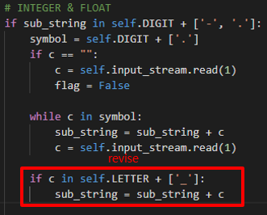

* Result

|  |  |  |
| --- | --- | --- |
| Input | Previous result | Revised result |
|  | ……    …… |  |

# IMPLEMENTATION

This project is comprised of mainly four parts: chess system, hardware (robot arm), network, computer vision.

## 1. Tokens, Alphabet

- We will implement this system using C++ language. Models for the system will be designed through many classes. They can stand for pieces, board, rules, etc. Any required information to store will be presented through these classes. Views, which will be implemented using the Qt framework, will display which pieces are located on the chess board now. The views are not related to the chess game directly, but it can show us what’s going on.

▲ Flow of the chess system working

## 2. ID-DFA

- We will use hardware specifically robot arm. This robot will have 5 Degree of freedom which includes gripper. This robot is mainly designed for move pieces of chess. The robot arm will be moved when it gets information from the network. Each of the motors will be controlled properly depending on the data such as moving location and piece type.

▲ Expected robot arm and chess piece

## 3. INTEGER – DFA

Code - def is_int

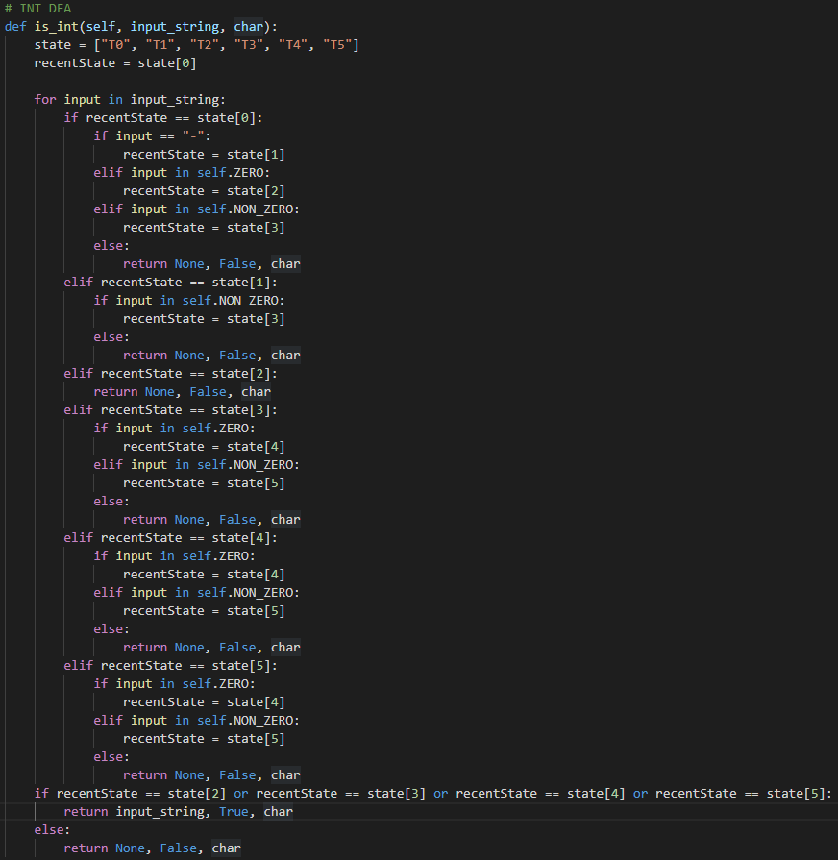

This part of code is for INT DFA that decides whether the input_string is int or not.

This method has 6 states, and the start state is T0.

In a for loop, it works exactly same as the INT DFA that was designed in the previous page.

This method reads input_string in order, and recent state is changed by input_string.

If it is finished in the final states which are state2, state3, state4 and state5, the input_string will be accepted.

Otherwise, the input_string will be denied, and it means input_string isn’t int.

## 4. FLOAT – DFA

Code – def is_float

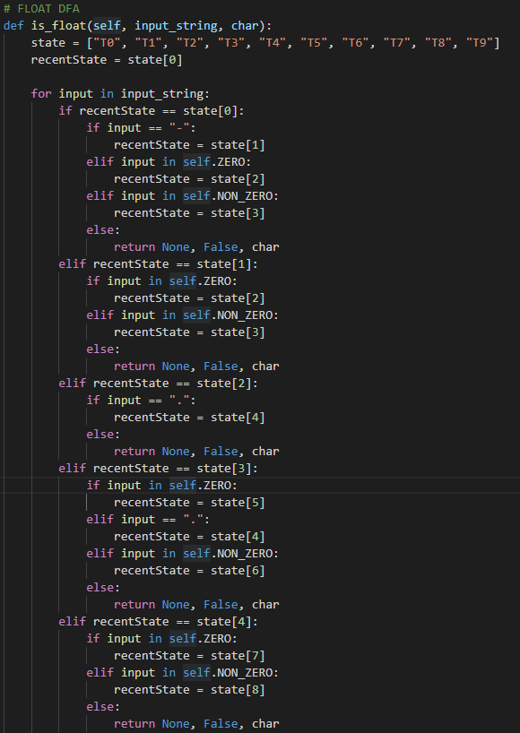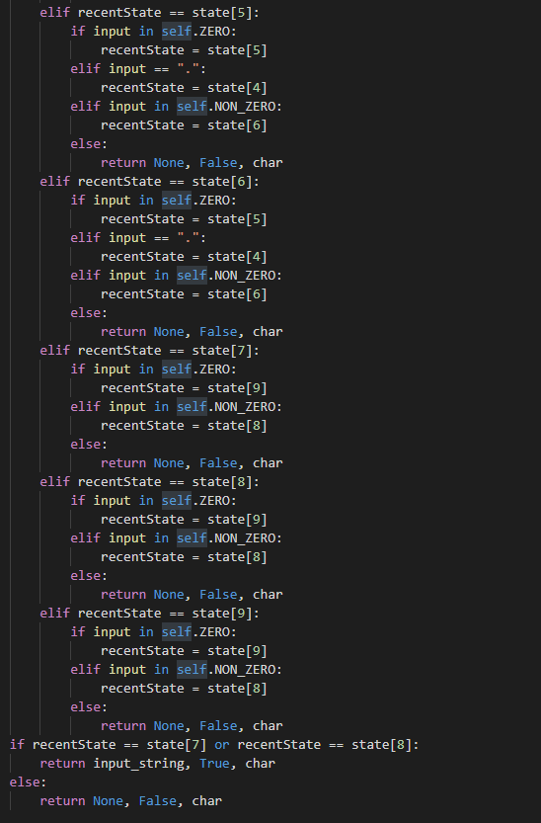

This part of code is for FLOAT DFA that decides whether the input_string is float or not.

This method has 10 states, and the start state is T0.

In a for loop, it works exactly same as the FLOAT DFA that was designed in the previous page.

This method reads input_string in order, and recent state is changed by input_string.

If it is finished in the final states which are state7 and state8, the input_string will be accepted.

Otherwise, the input_string will be denied, and it means input_string isn’t float.

## 5. LITERAL - DFA

- We use the OpenCV for computer vision. After taking pictures of a chessboard, we recognize each cell of the grid pattern as coordinate. And then we determine if a chess piece on each coordinate using object recognition. Finally, we discern the difference with two pictures that previous and recent ones to recognize the movement of the chess piece.

▲ Recognize coordinate

▲ Flow of the computer vision

# TEST CASES & RESULT

## 1. Correct Test Code - I

## 2. Correct Test Code - II

## 3. Error Test Code - I

|  |  |
| --- | --- |
| Input | Result |
| In our lexical analyzer, we don’t allow to use the character ‘$’. | |
|  |  |
| ‘=!’ isn’t correct comparison. | |
|  |  |
| ‘.0’ isn’t correct float. | |
|  |  |
| ‘1.10’ isn’t correct float. In our lexical analyzer, the right side of a decimal point must be a single digit 0 or a non-empty sequence terminating with a non-zero digit. | |
|  |  |
| ‘a.a’ isn’t correct input. | |
|  |  |
| ‘12people’ isn’t correct ID. ID should be started with English letter or ‘_’. | |
|  |  |
| ‘013’ isn’t corret int. | |
|  |  |
| ‘-0’ isn’t correct int. | |
|  |  |
| Literal string should be terminated with a symbol “. | |
|  |  |

# APPENDIX

## 1. NFA to DFA with transition table

* ID

* INTEGER

* FLOAT

* LITERAL

